**Tribhuvan University**

**Faculty of Humanities and Social Sciences**



**ATITHI: A HOMESTAY RESERVATION WEB APPLICATION**

**A PROJECT REPORT**

**Submitted to:**

**Department of Computer Application**

**Nepathya College**

**Tilottama-2, Rupandehi**

***In partial fulfillment of the requirements for the Bachelor’s in Computer Application***

**Submitted by:**

Pun Kishan TopBahadur [6-2-1182-11-2019]

Sunil Bhandari [6-2-1182-31-2019]

July, 2023



**Tribhuvan University**

**Faculty of Humanities and Social Sciences**

**Nepathya College**

**Supervisor’s Recommendation**

I hereby recommend that this project prepared under my supervision by Pun Kishan TopBahadur and Sunil Bhandari entitled **“ATITHI: A Homestay Reservation Web Application**” in partial fulfillment of the requirements for the degree in Bachelor of Computer Application is recommended for the final evaluation.

________________

Mr. Ananta Pandey

**SUPERVISIOR**



**Tribhuvan University**

**Faculty of Humanities and Social Sciences**

**Nepathya College**

**LETTER OF APPROVAL**

This is to verify that this project prepared by KISHAN PUN and SUNIL BHANDARI entitled **“ATITHI: A Homestay Reservation Web Application**” in partial fulfillment of the requirement for the degree of B.Sc. in Computer Science and Information Technology has been well studied. In our opinion it is satisfactory in the scope and quality as a project for the required degree.

|  |  |
| --- | --- |
| …………………………………  Mr. Ananta Pandey  Supervisor  Nepathya College | …………………………………  Mr. Sanjeev Bhandari  Principal  Nepathya College |
| …………………………………  Mr. Shiva Bhattarai  Internal Examiner Nepathya College | …………………………………  Mr. Soba Raj Poudel  External Examiner  Birendra Multiple Campus |

**Abstract**

**“ATITHI: A Homestay Reservation Web Application**” is a user-friendly homestay reservation website that connects travelers with welcoming hosts all over Nepal. With an intuitive search system, travelers can easily find their ideal homestay based on location. Host profiles feature genuine details and reviews ensuring a secure and trustworthy booking process. Through direct communication with hosts, travelers can gain valuable insights into the local culture, creating meaningful and enriching experiences during their stay. For hosts, ATITHI offers a platform to share their culture, offer warm hospitality, and earn extra income. Emphasizing cultural exchange and personalized experiences, ATITHI transforms conventional travel into an immersive journey of discovery and connection. In summary, “ATITHI” is a reliable and convenient homestay reservation website, connecting travelers with friendly hosts worldwide. The platform's intuitive search and filter system simplifies finding the perfect homestay, while authentic host profiles ensure a secure booking process. By enabling direct communication between hosts and guests, ATITHI fosters cultural exchange and enriching travel experiences. For hosts, it provides an opportunity to showcase their culture, extend warm hospitality, and generate additional income. Ultimately, ATITHI redefines travel, emphasizing meaningful connections and authentic experiences through homestay accommodations.

**ACKNOWLEDGEMENT**

The success and final outcomes of this project require a lot of guidance and assistance from many people and are very fortunate to have this all along the completion of this project. We are very glad to express our deepest sense of gratitude and sincere thanks to our highly respected and esteemed supervisor sir **Mr. Ananta Pandey**, Nepathya College for valuable supervision, guidance, encouragement and support for completing this work. All useful suggestions for this whole work and co-operative behavior are sincerely acknowledge.

Furthermore, I would also like to acknowledge with much appreciation the crucial role of coordinator, who gave the permission to use all required equipment and the necessary materials to complete my project. Special thanks go to my principal, **Mr. Sanjeev Bhandari**, who gave me valuable suggestions regarding the project. Last but not the least, many thanks go to my teachers, friends, guardians who directly or indirectly helped me in achieving the goal. I would like to appreciate all the guidance which has improved my presentation skills thanks to their comment and advices.

**Table of Contents**

Chapter 1 : Introduction 1

1.1 Introduction 1

1.2 Problem Statement 2

1.3 Objectives 2

1.4 Scope and limitation 2

1.5 Report Organization 3

Chapter 2 : Background Study and Literature Review 4

2.1 Background study 4

2.2 Literature Review 4

Chapter 3 : System Analysis and Design 5

3.1 System Analysis 5

3.1.1 Requirement Analysis 5

3.1.2 Feasibility Analysis 6

3.1.3 Data Modelling 8

3.1.4 Process Modelling 8

3.2. System Design 11

3.2.1 Architectural Design 11

3.2.2 Database Schema Design 11

3.2.3 Interface Design 12

3.2.4 Physical DFD 12

Chapter 4 : Implementation and Testing 13

4.1 Implementation 13

4.1.1 Tools Used 14

4.1.2 Implementation Detail of Modules 14

4.2 Testing 15

4.2.1 Test Cases for Unit Testing 15

4.2.2 Test cases for System Testing 16

Chapter 5 : Conclusion and Future Recommendations 18

5.1 Lesson Learnt/Outcome 18

5.2 Conclusion 18

5.3 Future Recommendation 18

Appendices 19

Supervisor Log Sheet 24

Reference 25

# List of Figures

Figure 3‑1 Use Case 5

Figure 3‑2 Gantt Chart 7

Figure 3‑3 ER Diagram 8

Figure 3‑4 DFD Level 0 8

Figure 3‑5 DFD Level 1 9

Figure 3‑6 DFD Level 2 10

Figure 4‑1 Waterfall Model 13

# List of Tables

Table 4‑1 Test Objective - Login from user 16

Table 4‑2 Test Objective – Book a Homestay 16

Table 4‑3 Test Objective – Searching the Homestay 17

Table 4‑4 Test Objective – Requesting the booking of the Homestay 17

Table 4‑5 Test Objective – Adding Homestay by the Owner 17

# List of Abbrivation

API: Application Programming Interface

CSS: Cascading Style Sheets

EJS: Embedded JavaScript

HTML: Hypertext Markup Language

HTTP: Hypertext Transfer Protocol

JS: JavaScript

MySQL: Structured Query Language (SQL) database management system

Node: Node.js

SQL: Structured Query Language

# : Introduction

## 1.1 Introduction

Welcome to “ATITHI”, your gateway to unforgettable homestay experiences all over Nepal ATITHI is an innovative and user-friendly reservation system designed to connect travelers with warm and welcoming hosts, providing them with an opportunity to immerse themselves in local cultures and create cherished memories. In a fast-paced travel industry, ATITHI stands out as a reliable and secure platform, dedicated to offering personalized and authentic homestay accommodations to enrich your journeys.

Our platform boasts an extensive database of diverse homestays, ranging from cozy countryside cottages to charming urban apartments, all carefully curated to meet your preferences and desires. Whether you seek a tranquil retreat in nature or an urban adventure amidst bustling neighborhoods, ATITHI has the perfect homestay for you.

At ATITHI, we understand that travel is more than just visiting destinations; it's about connecting with people, cultures, and traditions. With our emphasis on cultural exchange and direct communication between hosts and guests, we ensure that your stay becomes a transformative journey, offering insights into local customs, traditions, and hidden gems that you won't find in guidebooks.

Join us on this exciting adventure as we redefine the way you travel. ATITHI opens doors to new friendships, enriching experiences, and a sense of belonging, creating memories that will last a lifetime. So, let's embark on a journey together, discovering the world one homestay at a time with ATITHI!

## 1.2 Problem Statement

In the context of Nepal, the problem statement for the Homestay Reservation System are:

* Lack of a Centralized Platform for Homestay Bookings
* Limited Access to Authentic Local Homestays
* Safety and Security Concerns
* Limited Opportunities for Hosts to Market and Manage Homestays
* Lack of Standardized Booking Process

These are the problem to which we are aiming to solve through this project.

## 1.3 Objectives

The main objective of this project is to provide best local experience with safety and security.

* To provide Authentic Local Experiences
* To provide Convenient Booking Process
* To give Safety and Security
* To give Cross-cultural Communication and Language experience
* To help in Reporting and Analytics
* To provide faster and reliable mode of transportation.

## 1.4 Scope and limitation

* Scope
  1. Less time consuming.
  2. Easy to use.
  3. Cheaper than normal ride.
  4. Cultural Exchange and Communication:
  5. Extensive Homestay Database
* Limitation
  1. Depending on third party services
  2. Does not work in absence of WIFI or cellular network.

## 1.5 Report Organization

The report consists of five chapters in which all the phases of web application design and design development will be covered.

Chapter 1: The first chapter introduces the system and the problems it gives an overview about the project.

Chapter 2: The second chapter covers background study and literature review of the project.

Chapter 3: The third chapter covers the system analysis and design phase of the web application. It explains the methodology used while developing the system.

Chapter 4: The fourth chapter discuss about the implementation and testing phase of the web application development.

Chapter 5: The last chapter that is fifth chapter covers the conclusion, recommendation, and future works to improve this project.

# : Background Study and Literature Review

## 2.1 Background study

Online homestay reservation websites have played a significant role in facilitating this trend. These platforms act as intermediaries, connecting hosts with travelers from all around Nepal.

## 2.2 Literature Review

A literature review on homestay reservation systems would typically involve examining relevant academic papers, articles, and industry reports that focus on various aspects of homestay booking platforms. There aren’t any many articles about only homestay reservation systems in Nepal, so according to my research mostly hotel booking websites like Booking.com, Trivago, Goibibo many more which are similar to website which we have created also do the booking for the homestays.

Booking.com is one of the largest online travel agencies. It is headquartered in Amsterdam, and is a subsidiary of Booking Holdings. In 2022, the company's mobile app was the most downloaded mobile app in the travel agency category. [1]

Trivago N.V., marketed with lowercase styling as trivago, is a German technology company specializing in internet-related services and products in the hotel, lodging and metasearch fields. The company is headquartered in Düsseldorf. [2]

Expedia.com is an online travel agency owned by Expedia Group, based in in Seattle. The website and mobile app can be used to book airline tickets, hotel reservations, car rentals, cruise ships, and vacation packages. Expedia.com was launched on October 22, 1996 by Microsoft. [3]

Homestay reservation system we made is used to give experience to the user that come to our website and let them access to our features in our website. They can see the homestays add the owner and see all the facilities they provide also if they can contact to them directly as we provide them with information on the website. We give our full support to give the user of the authentic and culture rich experience through our website.

# : System Analysis and Design

## 3.1 System Analysis

Organizational requirement and functional part are deeply analyzed that help to achieve the objective of the organization.

### 3.1.1 Requirement Analysis

**I) Functional Requirements:**

A use case is a list of actions or event steps typically defining the interactions between a role (known in the Unified Modeling Language (UML) as an actor) and a system to achieve a goal. The actor can be a human or other external system. The use case diagram, which present the system requirements are used to show how the proposed system work. In practice. The interaction between actors is described using use case diagram. The functional requirement of the ATITHI web application is:

* + - Admin (i.e. owner of the Homestay) can view requests for booking of customers, and accept, deny them or notify the users.
    - Customer can search the place as per location and after searching they can also see the homestays at that place.

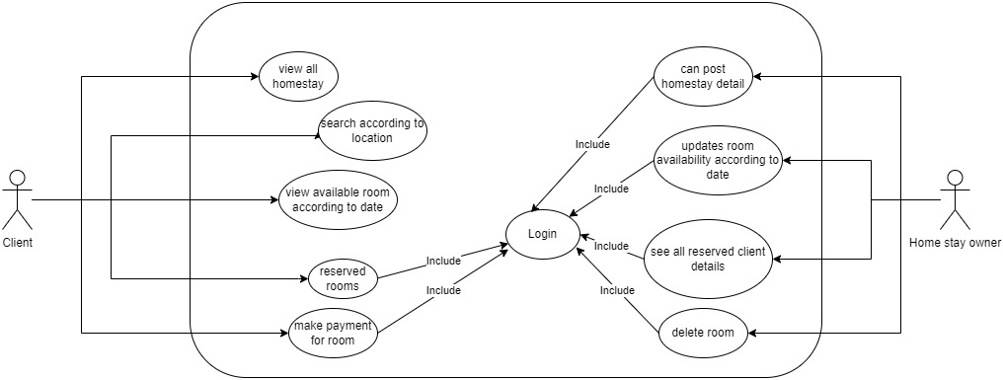

Figure 3‑1 Use Case

**ii) Non-Functional Requirements:**

* Availability:

It will be available online through our web application.

* Security:

This system will be secure and the user’s information won’t be available for others for user’s privacy.

* Performance:

This system will be designed for smooth performance with optimization and good response.

* Reliability:

It will be reliable for the user for their day-to-day life.

* Usability:

It is very for the customer to use.

### 3.1.2 Feasibility Analysis

Following feasibilities were studied before building the system to see if the system could be built with exact requirements in required time.

**Technical feasibility:**

In order to design this system, it uses off-self and existing technologies, software and hardware so there is no technological hurdle to build this system. For my web application a mobile phone or laptop or any other device for the user to book the homestay and for owner of the homestay is required.

**Operational feasibility:**

This system uses simple technologies to design. So, it is user friendly. It mostly solves the problem of searching for authentic homestays. There are many opportunities for this project as there is not much application available near me for this homestay reservation web app.

**Economic feasibility:**

The system does not require extra software and hardware i.e.; it uses open-source technologies. So, there is no recurring cost than just the internet connection.

**Schedule:**

This project takes time of 10-12 weeks to complete. There is are many barriers which I have to face some barriers are technical, technological, resource etc.

Figure ‑ Gantt Chart

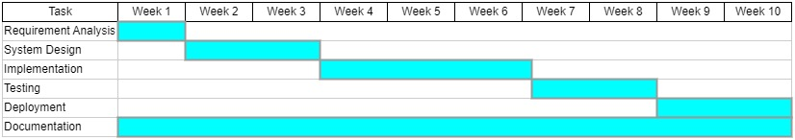

### 

### 3.1.3 Data Modelling

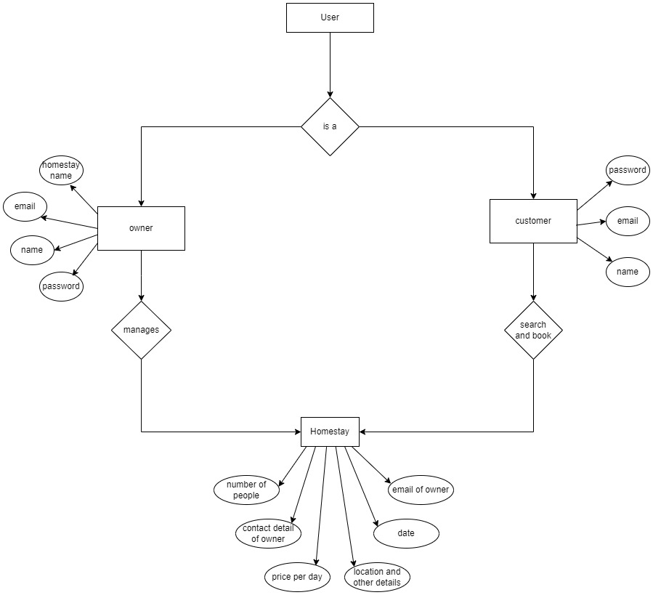

Figure 3‑3 ER Diagram

### 3.1.4 Process Modelling

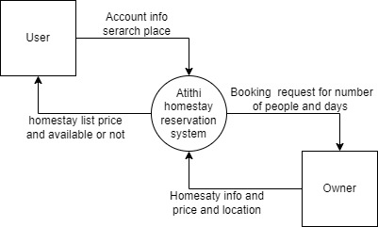

Figure 3‑4 DFD Level 0

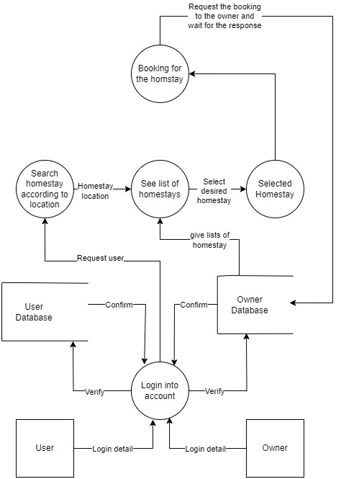

Figure 3‑5 DFD Level 1

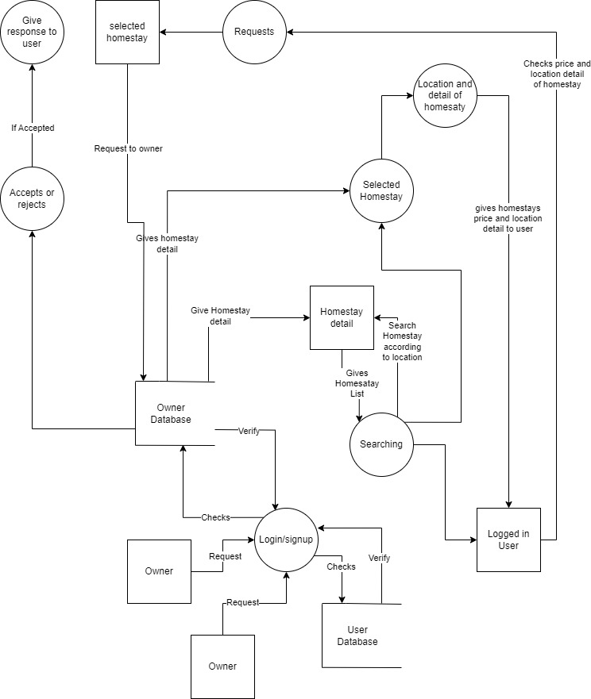

Figure 3‑6 DFD Level 2

## 3.2. System Design

System design is the process of defining the components, modules, interfaces, and data for a system to satisfy specified requirements. System development is the process of creating or altering systems, along with the processes, practices, models, and methodologies used to develop them.

### 3.2.1 Architectural Design

The software needs the architectural design to represents the design of software. IEEE defines architectural design as “the process of defining a collection of hardware and software components and their interfaces to establish the framework for the development of a computer system.” The software that is built for computer-based systems can exhibit one of these many architectural styles.

Software architecture is what makes it possible for innovation within an organization. The architecture used within their software must be of high quality, able to carry the load of work, ready when needed, and cost-effective. Software architecture is, simply, the organization of a system. This organization includes all components, how they interact with each other, the environment in which they operate, and the principles used to design the software. In many cases, it can also include the evolution of the software into the future.

### 3.2.2 Database Schema Design

Database schema design organizes the data into separate entities, determines how to create relationships between organized entities, and how to apply the constraints on the data. Designers create database schemas to give other database users, such as programmers and analysts, logical understanding of the data.

Databases that are inefficiently organized suck up tons of energy and resources, tend to be confusing, and are hard to maintain and administer. That’s where database schema design comes into play.

Without a clean, efficient, consistent database schema, you’ll struggle to make the best use of your enterprise data. For example, the same data might be duplicated in multiple locations—or even worse, might be inconsistent between these locations.

### 3.2.3 Interface Design

High level design of Atithi web application contains basic components.

**Input:**

It is the input of the owner. Owner will make changes to the homestays.

**Checker**:

Here data from owner is checked for validity. Any data that is invalid or data from invalid user are prevented from getting stored into database.

**Output:**

It is the result that user gets based on his/her input or request

### 3.2.4 Physical DFD

* + - Physical DFD depicts how the system will be implemented (or how the current system operates).
    - The processes represent the programs, program modules, and manual procedures.
    - The data stores represent the physical files and databases, manual files.
    - It shows controls for validating input data, for obtaining a record, for ensuring successful completion of a process, and for system security.

# : Implementation and Testing

## 4.1 Implementation

In this project to build a website I’m going to use waterfall methodology. This project has specific documentation, ample time, fixed requirements, well understood technology so in order to build this system, water fall methodology can be used.

The Waterfall Model was the first Process Model to be introduced. It is also referred to as a linear-sequential life cycle model. It is very simple to understand and use. In a waterfall model, each phase must be completed before the next phase can begin and there is no overlapping in the phases.

The Waterfall model is the earliest SDLC approach that was used for software development.

The waterfall Model illustrates the software development process in a linear sequential flow. This means that any phase in the development process begins only if the previous phase is complete. In this waterfall model, the phases do not overlap. [4]

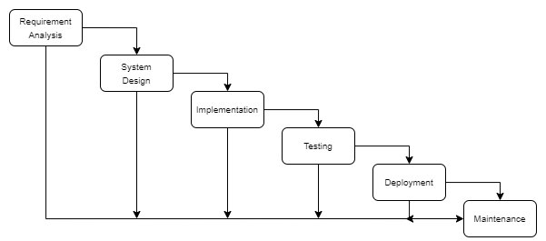

Figure ‑ Waterfall Model

### 4.1.1 Tools Used

**CASE Tool**

A computer-aided software engineering (CASE) tool is a software package that provides support for the design and implementation of information systems. It can document a database design and provide invaluable help in maintaining the consistency of a design.

**Language Used**

Frontend

* HTML
* CSS
* JavaScript
* Ejs (Embedded JavaScript Templating)
* Bootstrap V5

Backend

* Node js

Database

* MySql

### 4.1.2 Implementation Detail of Modules

For developing a website, I am going to use HTML, CSS, JavaScript, Ejs and MongoDB. For creating a web page HTML language helps to build login forms, table, image upload, and many more, which run in web browser. HTML (Hypertext Markup Language) is the most basic building block of the Web. It defines the meaning and structure of web content. Other technologies besides HTML are generally used to describe a web page's appearance/presentation CSS or functionality/behavior JavaScript.

Cascading Style Sheets (CSS) is a stylesheet language used to describe the presentation of a document written in HTML or XML (including XML dialects such as SVG or XHTML). CSS describes how elements should be rendered on screen, on paper, in speech, or on other media.

JavaScript (JS) is a lightweight, interpreted, or just in time compiled programming language with first-class functions While it is most well-known as the scripting language for Web pages, many non-browser environments also use it, such as Node.js, Apache. JavaScript is a prototype-based, multi-paradigm, single-threaded, dynamic language, supporting object-oriented, imperative, and declarative (e.g., functional programming) styles.

EJS (Embedded JavaScript Templating) is one of the most popular template engines for JavaScript. As the name suggests, it lets us embed JavaScript code in a template language that is then used to generate HTML. In this article, I will walk you through a detailed guide to templating your Node application with EJS.

Node.js is a cross-platform, open-source server environment that can run on Windows, Linux, Unix, macOS, and more. Node.js is a back-end JavaScript runtime environment, runs on the V8 JavaScript Engine, and executes JavaScript code outside a web browser.

Similarly, with Nodes, the system can connect to and manipulate database MySQL to store data which is entered or inputted. MySQL is the most popular Open-Source Relational SQL database management system. MySQL is one of the best RDBMS being used for developing web-based software applications.

## 4.2 Testing

Software Testing is a method to check whether the actual software product matches expected requirements and to ensure that software product is Defect free. It involves execution of software/system components using manual or automated tools to evaluate one or more properties of interest. The purpose of software testing is to identify errors, gaps or missing requirements in contrast to actual requirements.

4.2.1 Test Cases for Unit Testing

Unit Testing is a type of software testing where individual units or components of a software are tested. The purpose is to validate that each unit of the software code performs as expected. Unit Testing is done during the development (coding phase) of an application by the developers. Unit Tests isolate a section of code and verify its correctness. A unit may be an individual function, method, procedure, module, or object.

### 4.2.2 Test cases for System Testing

System Testing means testing the system as a whole. All the modules/components are integrated in order to verify if the system works as expected or not.

System Testing is done after Integration Testing. This plays an important role in delivering a high-quality product.

Table 4‑1 Test Objective - Login from user

|  |  |  |  |  |  |
| --- | --- | --- | --- | --- | --- |
| Test condition | Input data | Steps | Expected output | Actual Result | Result |
| For Login in | Enter email,  Password | 1.. Enter email  2.. Enter Password | User Successfully Logged in | Logged In | Pass |

Table 4‑2 Test Objective – Book a Homestay

|  |  |  |  |  |  |
| --- | --- | --- | --- | --- | --- |
| Test condition | Input data | Steps | Expected output | Actual Result | Result |
| User if not logged in then redirected to login page | Entering Location for the homestay | 1.. Enter the location  2.. Click search | List of homestays appears after clicking search then selecting the homestay the after choosing the desired homestay booking request | Redirected to Login page for user then again searching location | Pass |

Table 4‑3 Test Objective – Searching the Homestay

|  |  |  |  |  |  |
| --- | --- | --- | --- | --- | --- |
| Test condition | Input data | Steps | Expected output | Actual Result | Result |
| User searching for the homestay with the search option. | Entering Location for the homestay | 1.. Enter the location  2.. Click search | List of homestays appears after clicking search as per the location entered. | List of homestays are shown as expected. | Pass |

Table 4‑4 Test Objective – Requesting the booking of the Homestay

|  |  |  |  |  |  |
| --- | --- | --- | --- | --- | --- |
| Test condition | Input data | Steps | Expected output | Actual Result | Result |
| User request booking to the owner of the homestay | Entering user information in the booking form | 1.. Filling the booking form  2.. Click Book now | Filling the booking form then sending the request and the request pops up on owner’s page | After filling the form and sending request the request with the details pops up on the owner page | Pass |

Table 4‑5 Test Objective – Adding Homestay by the Owner

|  |  |  |  |  |  |
| --- | --- | --- | --- | --- | --- |
| Test condition | Input data | Steps | Expected output | Actual Result | Result |
| Owner adding the homestay in the system | Entering all the details of the homestay in the form | 1.. Enter the details  2.. Click add | Filling all the forms on the owner’s page and then showing in the system | After filling all the forms and adding then checking using location the homestay detail. | Pass |

# : Conclusion and Future Recommendations

## 5.1 Lesson Learnt/Outcome

The project focuses in developing a website that can give a homestay reservation system which includes prioritizing user experience, implementing robust security measures, ensuring scalability and performance, enabling clear communication between owner and user, automating reservation management, offering flexible booking options, displaying real-time availability and pricing, providing reliable customer support, utilizing data analytics for insights, continuous improvement, and compliance with legal considerations. By considering these factors, the system can enhance functionality, user satisfaction, and overall efficiency, leading to increased customer loyalty and business success.

## 5.2 Conclusion

With the development of this app people will have easy mode of transportation, also faster way of transportation. Specially people who are in hurry and want to get to desired location as soon as possible. People can choose their rider as who is near them. This app also helps the person who are in need of decent income with the help of their ride like bike. So, people can earn a decent income with their ride by becoming a rider and this makes more available rider in queue, which makes it easier for the passenger to not wait for a rider to become active as there will an available rider already.

## 5.3 Future Recommendation

My future recommendation for this web application is to make the website stable and fully automatic for the user. Afterwards to make it an actual mobile based application which work on both Android and IOS easily. This will make it easier for both user and owner so they don’t have to go the website again and again for booking and receiving request. Later on, to extend it on new places other than Nepal. So, people from outside Nepal can also make their life easier with our application and make their way to authentic homestay to desired location which will be better and much user friendly. [5]

# Appendices

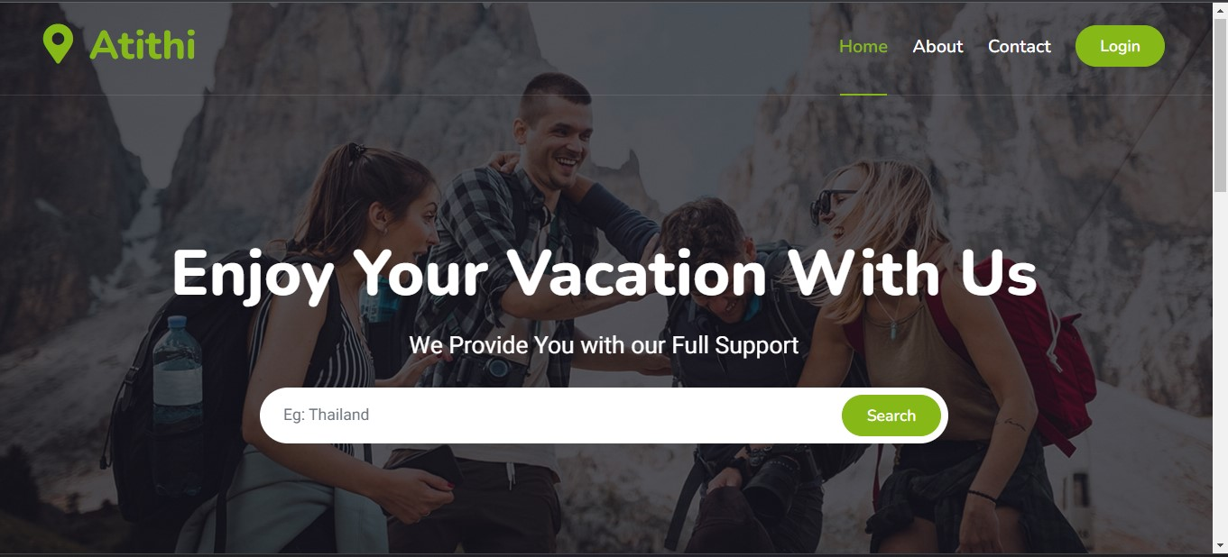

Index page

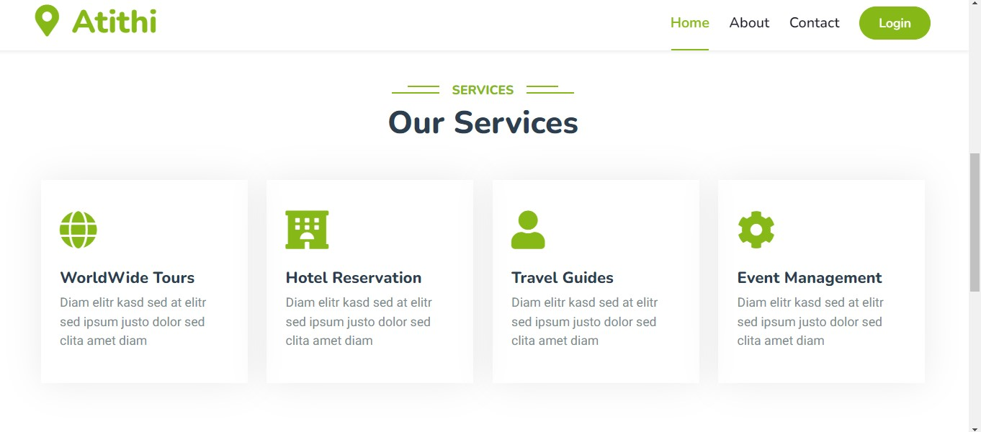

Same as index page

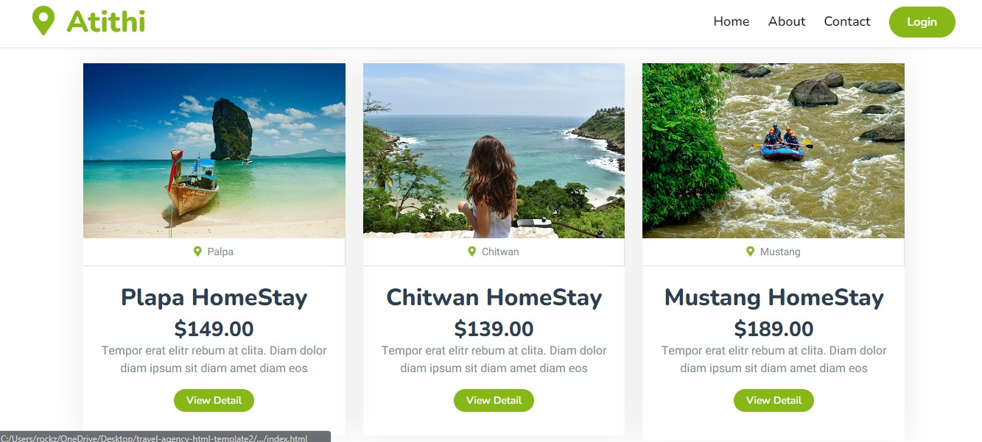

List of the homestays

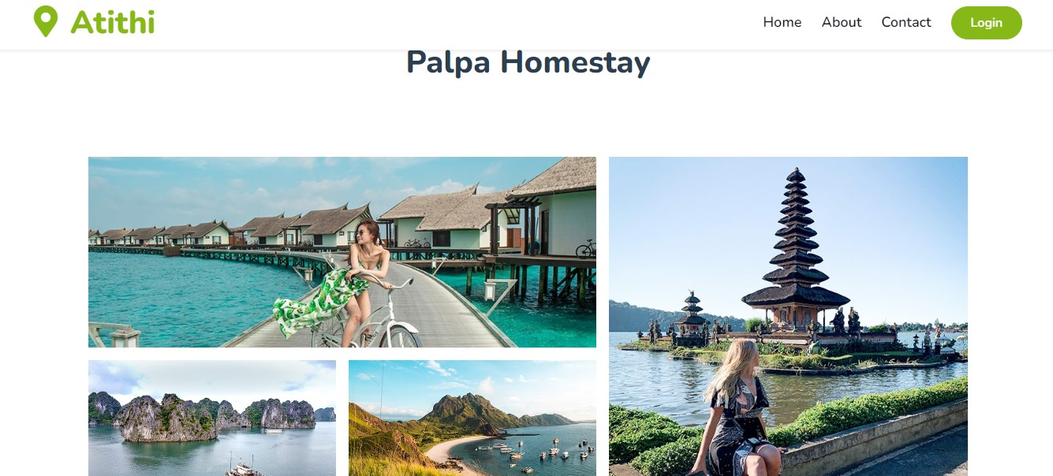

Detail of the selected Homestay

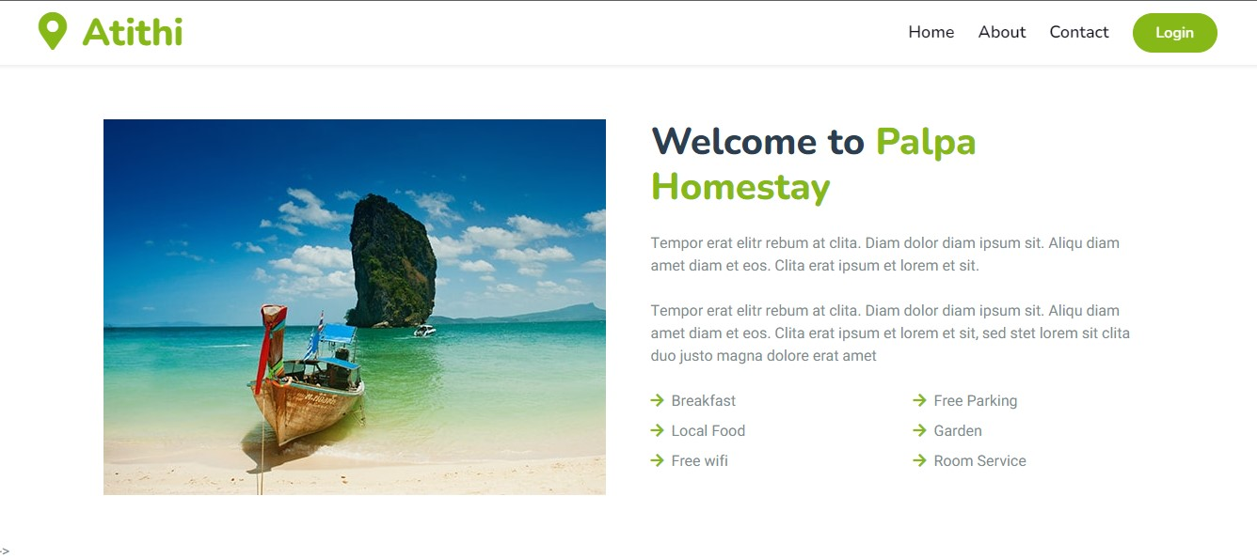

Same detail page

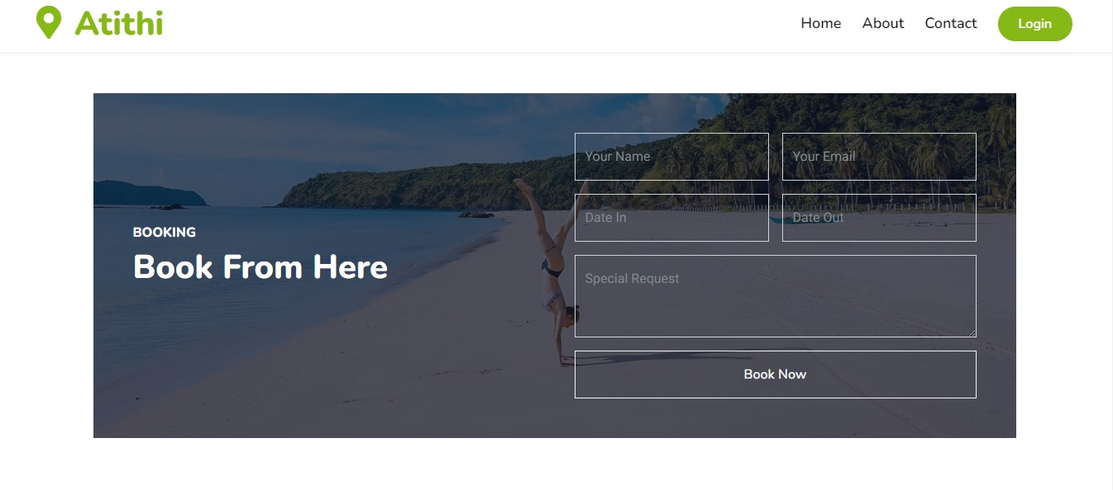

Booking Section of the detail page

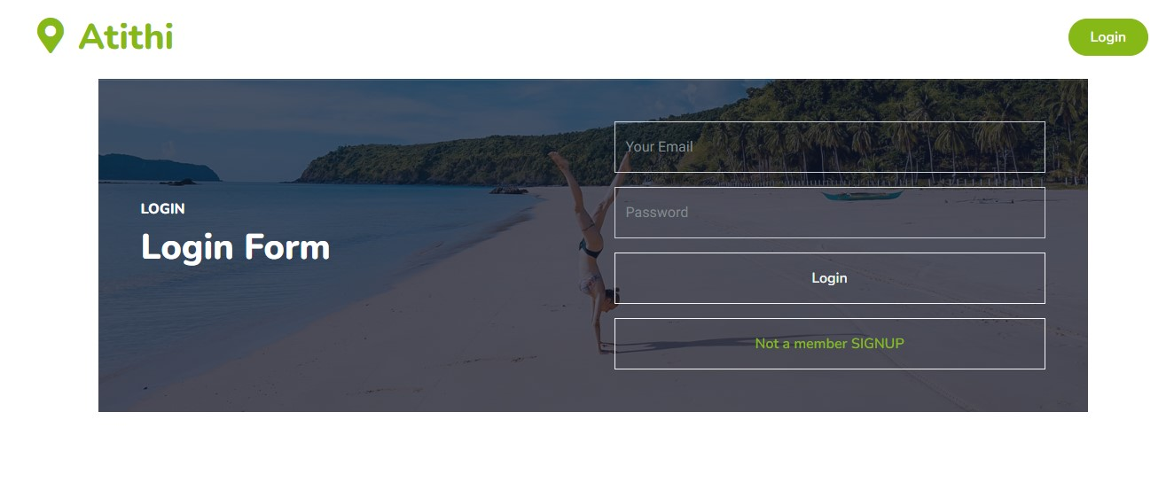

Login page

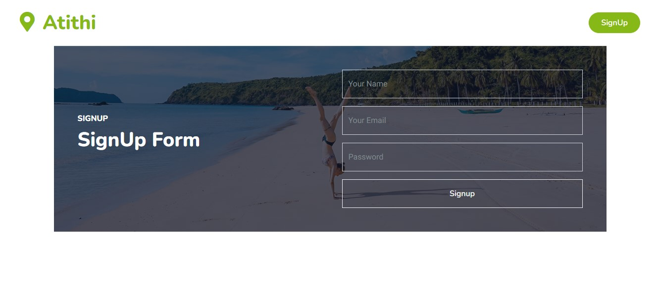

Signup page

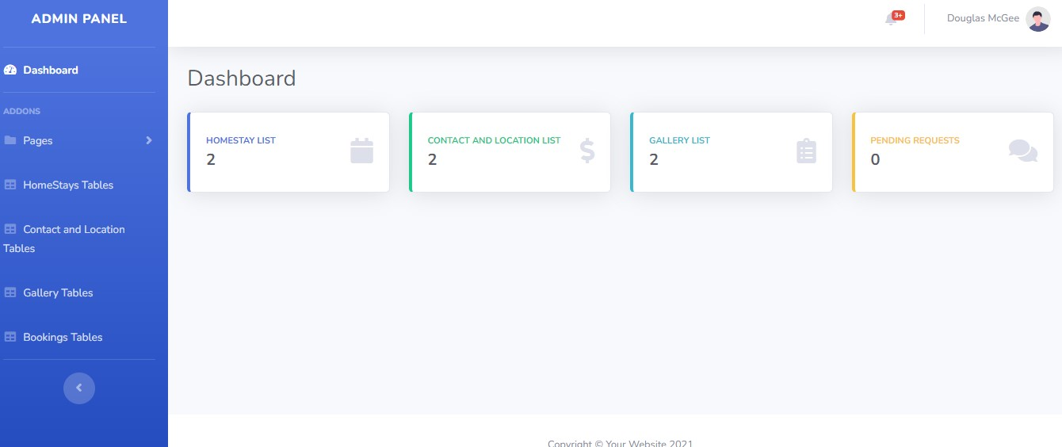

Owner Page/Admin panel

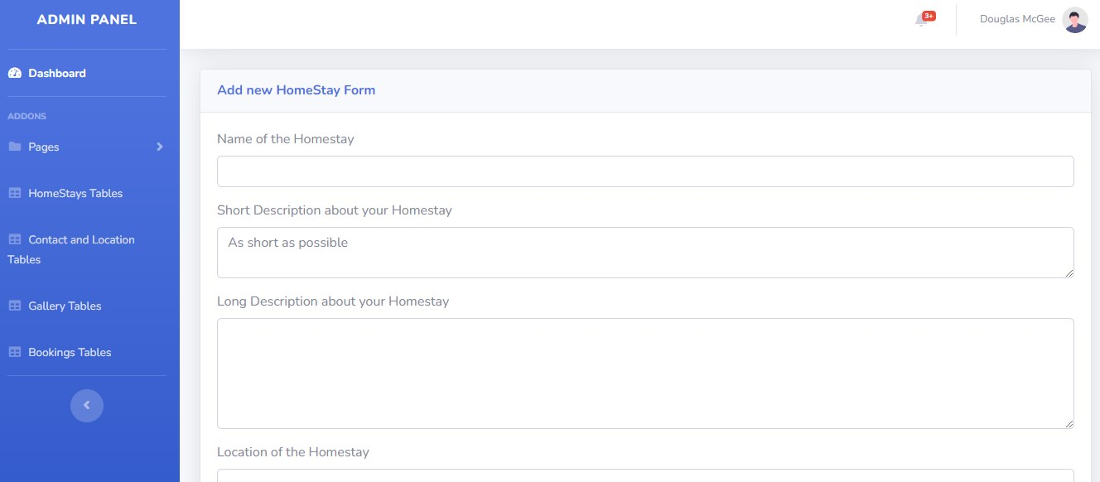

Adding New Homestay page

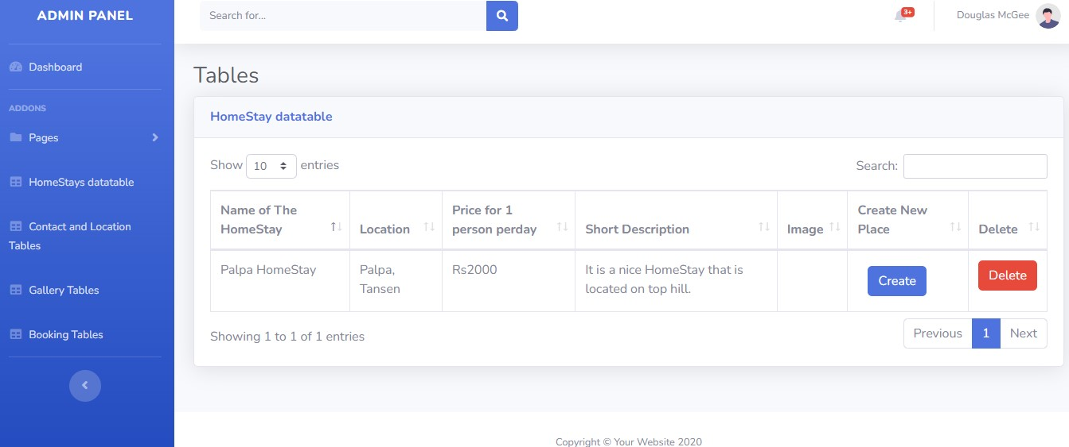

Table for added homestay page

# Supervisor Log Sheet

|  |  |  |  |  |
| --- | --- | --- | --- | --- |
| S.N | Date | Work Done | Supervisor  Comment | Signature |
| 1 | Jun 4 | Gathered information  about the project |  |  |
| 2 | Jun 11 | Started demo design of the project how to show |  |  |
| 3 | Jun 25 | Started the implementation our design into project |  |  |
| 4 | Jul 2 | Created backend and database routes to match with frontend |  |  |
| 5 | Jul 9 | Connected the frontend with backend and database |  |  |
| 6 | Jul 16 | Used different libraries and suitable implemented into our project |  |  |
| 7 | Jul 23 | Tested the system |  |  |
| 8 | Aug 6 | Gained expected output of the project |  |  |

# Reference

|  |  |
| --- | --- |
| [1] | "Booking.com," 30 July 2023. [Online]. Available: https://en.wikipedia.org/wiki/Booking.com. |
| [2] | "Trivago," 9 June 2023. [Online]. Available: https://en.wikipedia.org/wiki/Trivago. |
| [3] | "Expedia," 20 May 2023. [Online]. Available: https://en.wikipedia.org/wiki/Expedia. |
| [4] | B. Lutkevich, "Waterfall Model," November 2022. [Online]. Available: https://www.techtarget.com/searchsoftwarequality/definition/waterfall-model. |
| [5] | "Booking.com," Booking.com, 1996. [Online]. Available: https://www.booking.com/. [Accessed 8 Jul 2023]. |